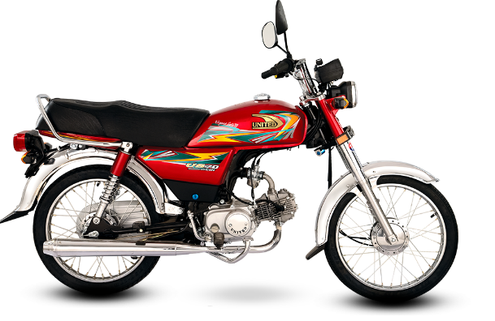

United 70cc Motorcycle (Karachi Only)

Product details of United 70cc Motorcycle (Karachi Only)

* Engine Type 4-Stroke OHC Single Cylinder cooled by Air
* Displacement 78CC
* Compression 8.1:1
* Front Brake Drum Mechanical
* Rear Brake Drum Mechanical
* Transmission 4-Speed
* Starting System Arm Assy Kick
* Fuel Tank Capacity8.5 Litre
* Tyre Front 2.25-17/4PR
* Tyre Rear 2.50-17/4PR
* Battery 12 Volt
* Engine Oil 0.7 Litre